Lex Testing 10.8.26

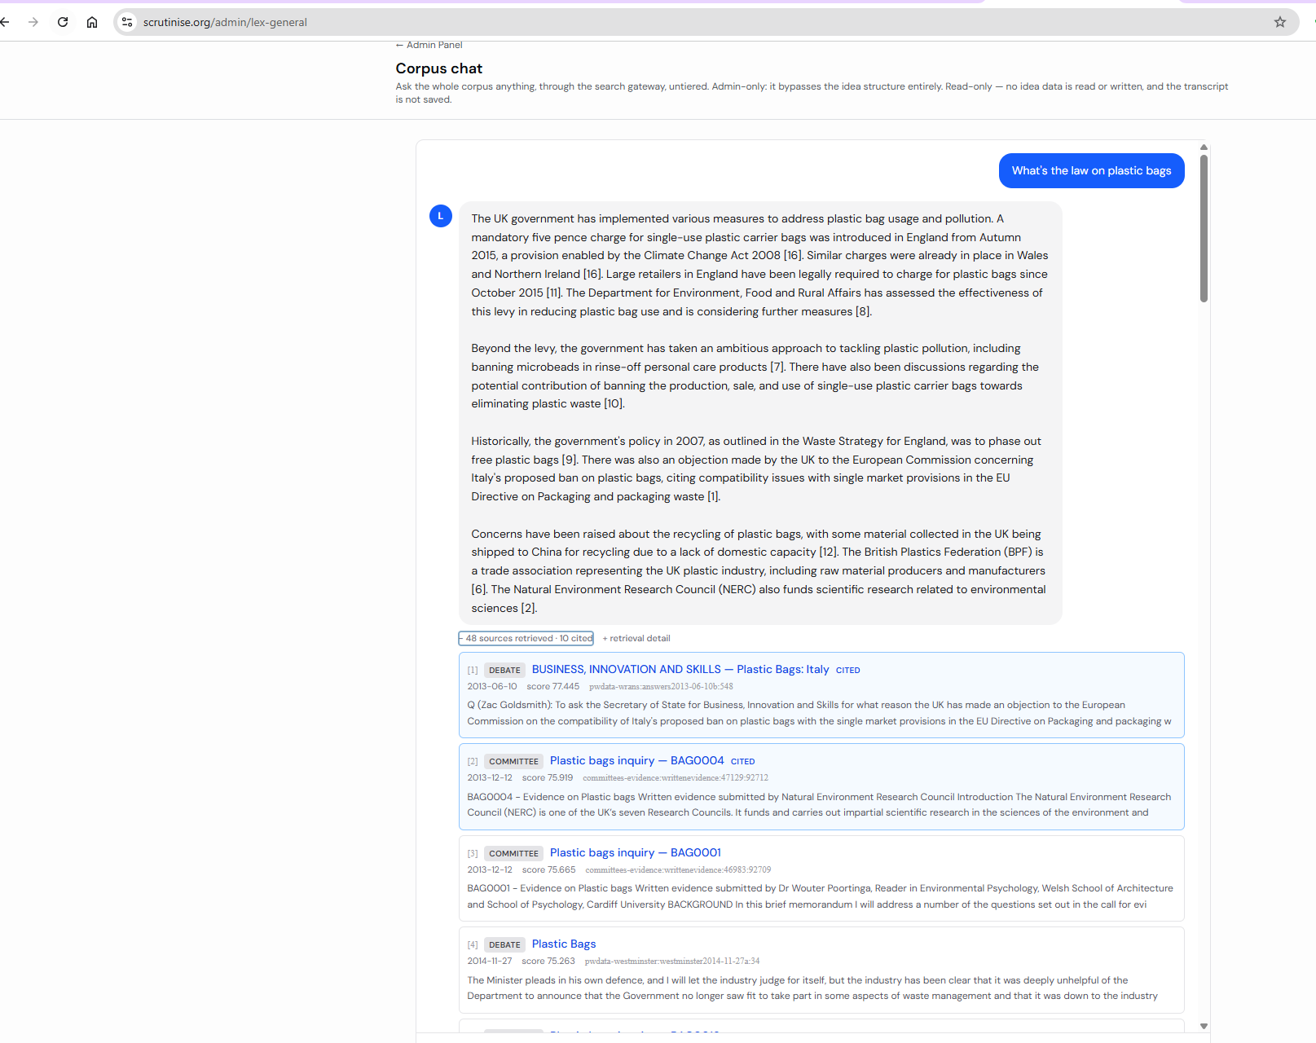
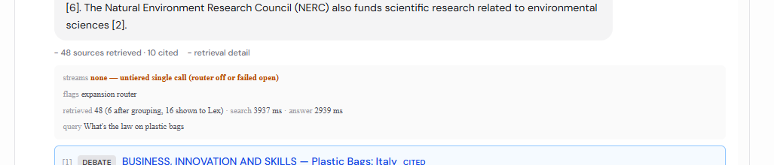
- [1]DebateBUSINESS, INNOVATION AND SKILLS — Plastic Bags: Italycited
2013-06-10score 77.445pwdata-wrans:answers2013-06-10b:548
Q (Zac Goldsmith): To ask the Secretary of State for Business, Innovation and Skills for what reason the UK has made an objection to the European Commission on the compatibility of Italy's proposed ban on plastic bags with the single market provisions in the EU Directive on Packaging and packaging w

- [2]CommitteePlastic bags inquiry — BAG0004cited
2013-12-12score 75.919committees-evidence:writtenevidence:47129:92712
BAG0004 - Evidence on Plastic bags Written evidence submitted by Natural Environment Research Council Introduction The Natural Environment Research Council (NERC) is one of the UK’s seven Research Councils. It funds and carries out impartial scientific research in the sciences of the environment and

- [3]CommitteePlastic bags inquiry — BAG0001
2013-12-12score 75.665committees-evidence:writtenevidence:46983:92709
BAG0001 - Evidence on Plastic bags Written evidence submitted by Dr Wouter Poortinga, Reader in Environmental Psychology, Welsh School of Architecture and School of Psychology, Cardiff University BACKGROUND In this brief memorandum I will address a number of the questions set out in the call for evi

- [4]DebatePlastic Bags
2014-11-27score 75.263pwdata-westminster:westminster2014-11-27a:34
The Minister pleads in his own defence, and I will let the industry judge for itself, but the industry has been clear that it was deeply unhelpful of the Department to announce that the Government no longer saw fit to take part in some aspects of waste management and that it was down to the industry

- [5]CommitteePlastic bags inquiry — BAG0019
2013-12-12score 74.726committees-evidence:writtenevidence:47205:92749
BAG0019 - Evidence on Plastic bags Written evidence submitted by Novamont, the Kyoto Club, The Italian Association of Bioplastics and the Italian Composting Association Executive Summary: 1.1. We are a group of Italian organisations looking to provide the Committee with information on the effect of

- [6]CommitteePlastic bags inquiry — BAG0011cited
2013-12-12score 74.055committees-evidence:writtenevidence:47174:92718
BAG0011 - Evidence on Plastic bags Written evidence submitted by Br itish Plastics Federation (BPF) Background of the Association The BPF is the leading trade association for the UK Plastic Industry representing the views of the raw material producers, additives suppliers and manufacturers of semi-f

- [7]DebateDepartment for Environment, Food and Rural Affairs — Plastics: Pollutioncited
2023-09-12score 74.042pwdata-lordswrans:lordswrans2023-09-12:5
Q (Lord Redesdale): To ask His Majesty's Government what steps they are taking to (1) prevent, (2) reduce, and (3) eliminate, plastic pollution. A (Lord Benyon): The Government has taken an ambitious approach to tackling plastic pollution. We have already banned microbeads in rinse-off personal care

- [8]DebateDepartment for Environment, Food and Rural Affairs — Plastic Bags: Fees and Chargescited
2026-02-02score 73.764pwdata-wrans:answers2026-02-02:38
Q (Max Wilkinson): To ask the Secretary of State for Environment, Food and Rural Affairs, what assessment her Department has made of the effectiveness of the plastic bag levy at lowering use; and whether she plans to introduce further measures to reduce the use of single-use plastic bags. A (Mary Cr

- [9]DebateTREASURY — Taxation: Plastic Bagscited
2008-01-17score 73.605pwdata-wrans:answers2008-01-17b:120
Q (Eric Pickles): To ask the Chancellor of the Exchequer what the Government's policy is on the proposals in the London Local Authorities Bill to introduce a new additional plastic bags tax on shops in London. A (Angela Eagle): The Government pledged in the Waste Strategy for England 2007 to phase o

- [10]DebateDepartment for Environment, Food and Rural Affairs — Plastic Bagscited
2019-04-29score 73.583pwdata-wrans:answers2019-04-29:193
Q (Catherine McKinnell): To ask the Secretary of State for Environment, Food and Rural Affairs, what recent assessment he has made of the contribution that banning the production, sale and use of single-use plastic carrier bags could make towards achieving his Department's target of eliminating all

- [11]DebateDepartment for Environment, Food and Rural Affairs — Plastic Bagscited
2020-09-02score 73.309pwdata-wrans:answers2020-09-02:40
Q (Wera Hobhouse): To ask the Secretary of State for Environment, Food and Rural Affairs, how many plastic bags for life have been sold in each year since the introduction of the plastic bag levy in 2015. A (Rebecca Pow): Since 5 October 2015, large retailers in England have been required by law to

- [12]DebateBusiness of the House — Topical Debate — Supermarketscited
2008-04-24score 73.213pwdata-debates:debates2008-04-24c:242
The hon. Lady is exactly right. I entirely agree with her. Some of the material collected does not get used in this country. Plastic bags are an example. We collect the plastic and ship it over to China, because it can use it and we cannot. We have nowhere that can recycle the plastic from plastic b

- [13]CommitteePlastic bags inquiry — BAG0002
2013-12-12score 72.035committees-evidence:writtenevidence:47084:92710
BAG0002 - Evidence on Plastic bags Written evidence submitted by Regain Polymers Limited Executive summary: In my capacity as both Purchasing Director of Regain Polymers Limited and Vice Chair of the British Plastics Federation Recycling Group, I make the following written submission to the Environm

- [14]CommitteePlastic bags inquiry — BAG0003
2013-12-12score 71.987committees-evidence:writtenevidence:47122:92711
BAG0003 - Evidence on Plastic bags Written evidence submitted by PlasR ecycle Limited SUMMARY We do not oppose a levy on plastic bags. However, t he promotion of degradable b ags via a levy exe mption would be a very bad idea since such bags (both bio-degradable and oxo -degradable) , according to s

- [15]CommitteePlastic bags inquiry — BAG0022
2013-12-12score 71.773committees-evidence:writtenevidence:47211:92729
BAG0022 - Evidence on Plastic bags Written evidence submitted by Keep Britain Tidy Keep Britain Tidy is an independent environmental charity, which campaigns for people’s right to live and work in a place of which they can be proud. A single truth underpins our success – caring for the environment i

- [16]CommitteeReport: 11th Report - Plastic bags (Report, together with formal minutes relating to the report) — Environmental Audit Committee — Plastic bags 5cited
2014-02-06score 71.596committees-reports:publication:10346:arc-0003
Plastic bags 5 1 Background 1. In September 2013 the Deputy Prime Minister announced plans to introduce a mandatory five pence charge for single-use plastic carrier bags in England from Autumn 2015. 1 The provision for such a charge h ad been included in the Climate Change Act 2008. 2 Wales and Nort
- retrieved but not shown to Lex
- [17]CommitteePlastic bags inquiry — BAG0031
2013-12-19score 71.555committees-evidence:writtenevidence:47293:92934
BAG0031 - Evidence on Plastic bags Written evidence submitted by WRAP (the Waste & Resources Action Programme) Executive Summary 1. WRAP welcomes the opportunity to provide written evidence to the Environmental Audit Committee’s Inquiry into the sustainability of measures to reduce the use of plasti

- [18]DebateStop using plastic bags packages on food products
2022-06-09score 71.504petitions:618180:1
Stop using plastic bags packages on food products State: rejected · Signatures: 8 Promote a law to decrase close to zero the plastic bags and package We are about to face a huge crisis due to climate change, it is important to promote a circular thinking raragaer than disposable, plastic can be sub

- [19]DebateDepartment for Environment, Food and Rural Affairs — Plastic Bags: Charities
2021-11-16score 71.433pwdata-lordswrans:lordswrans2021-11-16:47
Q (Lord Storey): To ask Her Majesty's Government what assessment they have made, if any, of the environmental impact of the fundraising practice of delivering plastic charity bags to millions of households. A (Lord Goldsmith of Richmond Park): The Government’s 25 Year Environment Plan sets out our a

- [20]DebateNORTHERN IRELAND — Plastic Bags
2006-10-30score 71.320pwdata-wrans:answers2006-10-30e:448
Q (Mark Durkan): To ask the Secretary of State for Northern Ireland what estimate he has made of the number of plastic bags produced for the local retail sector in each of the last three years; what assessment he has made of the environmental impact of plastic bags; what initiatives his Department i

- [21]DebateENVIRONMENT FOOD AND RURAL AFFAIRS — Packaging: Plastics
2008-01-14score 71.194pwdata-wrans:answers2008-01-14e:147
Q (Joan Walley): To ask the Secretary of State for Environment, Food and Rural Affairs what progress his Department has made on reducing the use of plastic bags; and what assessment he has made of the effectiveness of the Irish government's policy on the matter. A (Joan Ruddock): The Government have

- [22]DebatePLASTIC BAGS
2008-04-28score 71.114early-day-motions:35702:1
PLASTIC BAGS EDM 1441 · Tabled: 2008-04-28 · Primary sponsor: Norman Baker (Liberal Democrat, Lewes) · Signatures: 54 That this House welcomes the increased attention in the press to the pollution caused by plastic bags; notes official figures which show that one in 10 public spaces is littered with

- [23]CommitteePlastic bags inquiry — BAG0008
2013-12-12score 71.056committees-evidence:writtenevidence:47161:92715
BAG0008 - Evidence on Plastic bags Written evidence submitted by The Industry Council for Research on Packaging and the Environment (INCPEN) INCPEN is a research body established in 1974 to consider the environmental and social impacts of packaging. INCPEN members represent all stages of the supply

- [24]DebateDepartment for Environment, Food and Rural Affairs — Plastic Bags: Fees and Charges
2018-10-22score 71.055pwdata-wrans:answers2018-10-22:231
Q (Mr Jim Cunningham): To ask the Secretary of State for Environment, Food and Rural Affairs, what assessment he has made of the effectiveness of the single use carrier bag charge; and whether he has plans to expand the scheme to other single use items. A (Dr Thérèse Coffey): The single use carrier

- [25]DebateSingle-use Plastics - Question
2020-02-27score 71.011pwdata-lords:daylord2020-02-27b:5
My Lords, further to the noble Baroness’s question about banning plastics altogether, at the moment the supermarkets seem to be having their cake and eating it. They are charging us for our plastic bags but not all of that money is going to charity. Some of it is being kept by the supermarkets. Furt

- [26]DebateENVIRONMENT FOOD AND RURAL AFFAIRS — Plastic Bags
2008-05-07score 70.878pwdata-wrans:answers2008-05-07c:66
Q (Keith Vaz): To ask the Secretary of State for Environment, Food and Rural Affairs what estimate he has made of the number of plastic bags used (a) by supermarket shoppers in the last 12 months and (b) in England in the last 10 years. A (Joan Ruddock): The Waste and Resources Action programme (WRA

- [27]CommitteeCoffee Cups and Plastic Bottles: disposable packaging inquiry — PKG0026
2017-04-25score 70.700committees-evidence:writtenevidence:79428:125316
PKG0026 - Evidence on Packaging PKG0026 Written evidence submitted by Professor Wouter Poortinga , Professor of Environmental Psychology, Welsh School of Architecture and School of Psychology, Cardiff University BACKGROUND In this memorandum I will address a number of the questions relating to w hat

- [28]DebateCABINET OFFICE — Plastic Bags
2013-09-03score 70.634pwdata-wrans:answers2013-09-03a:81
Q (Zac Goldsmith): To ask the Minister for the Cabinet Office what work his Department's Behavioural Insight Team (a) has undertaken and (b) plans to undertake on reducing public plastic bag usage. A (Nick Hurd): The Behavioural Insights Team has not undertaken, nor does it currently have plans to u

- [29]CommitteeSpecial Report: 8th Special Report - Departmental Annual Report 2012-13: Government Response to the Committee's Ninth Report of Session 2013-14 — Environment, Food and Rural Affairs Committee — 12 Eighth Special Report of Session 2013–14
2014-05-14score 70.623committees-reports:publication:10676:arc-0012
12 Eighth Special Report of Session 2013–14 Defra is undertaking an independent evaluation into the wider impacts of the approach to ensure that partnership funding continues to achieve its core objectives of increasing levels of external funding for flood defence projects, enabling greater local ch

- [30]DebateENVIRONMENT FOOD AND RURAL AFFAIRS — Plastics: Packaging
2007-11-28score 70.520pwdata-wrans:answers2007-11-28c:188
Q (Stephen Hesford): To ask the Secretary of State for Environment, Food and Rural Affairs what assessment he has made of the merits of seeking the introduction of tax on plastic bags to encourage the use of recyclable alternatives; and what discussions he has had with the Chancellor of the Excheque

- [31]DebateJUSTICE — Plastic Bags
2008-02-05score 70.378pwdata-wrans:answers2008-02-05e:367
Q (Bob Neill): To ask the Secretary of State for Justice (1) how many branded plastic bags his Department and its agencies have purchased since his Department was created; and at what cost; (2) pursuant to the answer of 7 January 2008, Official Report, column 171W, on procurement, how many plastic b

- [32]CommitteePlastic bags inquiry — BAG0009
2013-12-12score 70.322committees-evidence:writtenevidence:47164:92716
BAG0009 - Evidence on Plastic bags Written evidence submitted by Foodservice Packaging Association SUMMARY OF FPA RESPONSE The Foodservice Packaging Association although not in favour of a compulsory charge on bags of any material is not opposing the proposal to apply a 5p charge to plastic bags. We

- [33]DebateDepartment for Environment, Food and Rural Affairs — Plastic Bags
2017-11-21score 70.312pwdata-lordswrans:lordswrans2017-11-21:31
Q (lord laird): To ask Her Majesty's Government what assessment they have made of the effectiveness of policies designed to reduce the use of plastic bags by retailers and consumers; and what further policies they envisage in that area. A (lord gardiner of kimble): Since the introduction of the 5 pe

- [34]DebateReusable Carrier Bags
2002-11-27score 70.305pwdata-westminster:westminster2002-11-27:78
I accept that my hon. Friend's views are genuine, and I agree with many of them. He has been a strong supporter of the measure for a long time, and I shall deal with some of his arguments. We must consider whether the sacrifice that may have to be made in terms of the number of jobs throughout the c

- [35]Debate[Mrs. Joan Humble in the Chair] — Packaging Manufacturing Industry
2007-06-12score 70.241pwdata-westminster:westminster2007-06-12b:15
I have a figure somewhere showing that given the amount of moisture in cucumbers, they can in fact benefit from being packaged. On the hon. Gentleman's point about plastic bags, which I know a little bit about, when the tax on plastic carrier bags was imposed in Ireland, the demand for other types o

- [36]DebateENVIRONMENT FOOD AND RURAL AFFAIRS — Plastic Bag Tax
2005-10-31score 70.234pwdata-wrans:answers2005-10-31c:52
Q (Daniel Rogerson): To ask the Secretary of State for Environment, Food and Rural Affairs what assessment she has made of the merits of a plastic bag tax; and if she will make a statement. A (Ben Bradshaw): The Government recognize the benefits of reducing the number of plastic bags used, but does

- [37]DebateProhibit the unsolicited delivery of plastic bags
2022-03-17score 70.197petitions:611788:1
Prohibit the unsolicited delivery of plastic bags State: closed · Signatures: 31 · Opened: 2022-03-25 The Government should prohibit the delivery of plastic bags, where these have not been requested. Many charities bulk mail plastic bags, for use to give donations, to households across the country.

- [38]DebateDepartment for Environment, Food and Rural Affairs — Plastics: Packaging
2022-04-26score 70.196pwdata-lordswrans:lordswrans2022-04-26:8
Q (Baroness Bennett of Manor Castle): To ask Her Majesty's Government, further to the discovery of microplastics in the lungs and blood of living people, what plans they have to accelerate the phase-out of single-use plastic packaging and containers. A (Lord Goldsmith of Richmond Park): This governm

- [39]DebateDepartment for Environment, Food and Rural Affairs — Plastics: Small Businesses
2023-09-12score 70.142pwdata-wrans:answers2023-09-12:215
Q (Bambos Charalambous): To ask the Secretary of State for Environment, Food and Rural Affairs, what recent steps her Department has taken to help ensure small businesses reduce their use of single-use plastics. A (Rebecca Pow): Building on the success of our existing restrictions on certain single

- [40]CommitteeReport: 11th Report - Plastic bags (Report, together with formal minutes relating to the report) — Environmental Audit Committee — Plastic bags 15 — ¶34
2014-02-06score 70.062committees-reports:publication:10346:arc-0014
34. Actual usage of more durable bags depends on people changing their habits to b r in g bags with them. A th in bag f or lif e needs to be used four times as of te n as a s in gl e-use plastic bag used once, and thicker bags for life would need to be used 11 times as of t en (Figure 2). Ireland, r

- [41]CommitteePlastic bags inquiry — BAG0013
2013-12-12score 70.058committees-evidence:writtenevidence:47188:92721
BAG0013 - Evidence on Plastic bags Written evidence submitted by Marine Conservation Society Th e Marine Conservation Society ( MCS) is the UK charity dedicated to the protection of the UK ’s seas, shores and wildlife. MCS campaigns for clean seas and beaches, sustainable fisheries, protection of ma

- [42]DebateENVIRONMENT FOOD AND RURAL AFFAIRS — Plastic Bags
2011-06-21score 69.899pwdata-wrans:answers2011-06-21d:273
Q (Zac Goldsmith): To ask the Secretary of State for Environment, Food and Rural Affairs what her policy is on the European Commission's proposal for an EU-wide ban on plastic carrier bags. A (Richard Benyon): We support the Commission's consultation looking at the possible options for the reduction

- [43]DebatePlastic Bags
2011-06-06score 69.862pwdata-lordswrans:lordswrans2011-06-06a:92
Q (Lord Stoddart of Swindon): To ask Her Majesty's Government what is their assessment of the possibility raised by Mr Janez Potocnik, European Union Environmental Commissioner, of a European Union-wide ban on plastic carrier bags. A (Lord Henley): The Commission is currently consulting on a number

- [44]DebateUrban Rat and Fox Populations: Plastic Rubbish Bags
2001-03-21score 69.831pwdata-lordswrans:lordswrans2001-03-21a:6
Q (Lord Swinfen): asked Her Majesty's Government: Whether the urban population of rats has increased since the introduction of plastic rubbish bags; and, if so, by what estimated percentages; and Whether the urban population of foxes has increased since the introduction of plastic rubbish bags; and,

- [45]CommitteePlastic bags inquiry — BAG0021
2013-12-12score 69.819committees-evidence:writtenevidence:47208:92728
BAG0021 - Evidence on Plastic bags Written Evidence Submitted by Centriforce Products Ltd Summary Centriforce Products does not oppose any levy on ‘single use’ plastic bags Centriforce Products, as an established reprocesssor of waste plastic materials [see introduction below], has major concerns ab

- [46]DebateScottish Parliament: Environment and Rural Development Committee, 28 Sep 2005 [The Convener opened the meeting at 10:34]
score 69.767scottish-parliament-or:arch-971:5
You are referring to the SSPCA's submission. I will let its representative speak in a second. You asked about bin-liners. Our submission mentions a Cuvier's beaked whale that was washed up in Scotland in which fishing twine and black bin-liners were found. The other examples that we provided to the

- [47]CommitteeSpecial Report: 1st Special Report - Plastic bags: Government response to the Committee's Eleventh Report of Session 2013-14 — Environmental Audit Committee — 2 Environmental Audit Committee
2014-06-17score 69.754committees-reports:publication:10761:arc-0003
2 Environmental Audit Committee coherence with wider strategies for reducing and managing waste, and the exemption could also undermine the reduction in bag use from the 5p charge. It is important that the Government gets the proposals for the carrier bag charge right, as it is one of the simplest a

- [48]DebatePlastic Bags
2012-10-17score 69.751pwdata-westminster:westminster2012-10-17a:51
I thank my hon. Friend for his intervention. I am told that the figure is closer to 1.5%, but I shall not quibble with what he says. However, I do not see that as an argument against a measure to reduce the use of plastic bags. Plastic bags have a disproportionate impact. We are told that 16% of all

Clicking through works, taking me to the document behind it.

This test didn’t work – the plan was the info wouldn’t be in the data but it was!
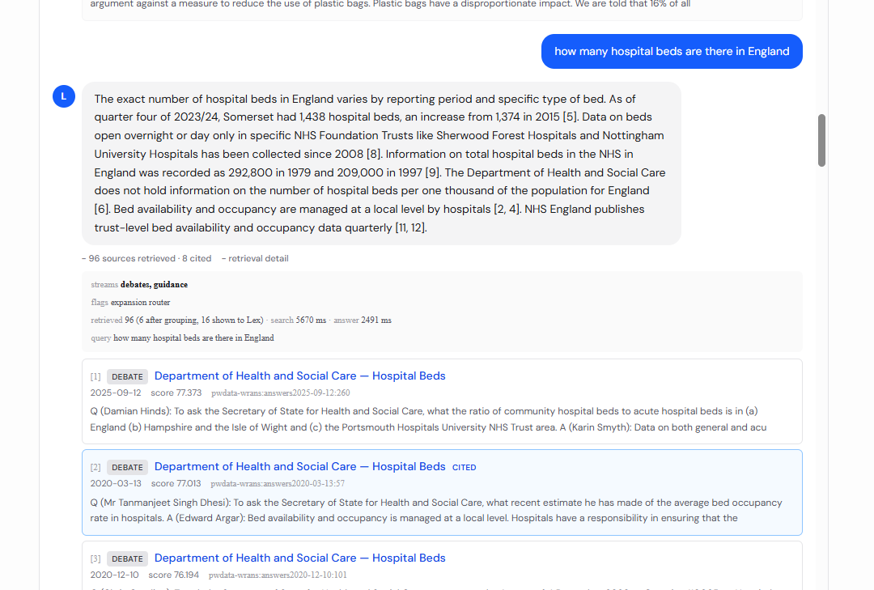

However this did:
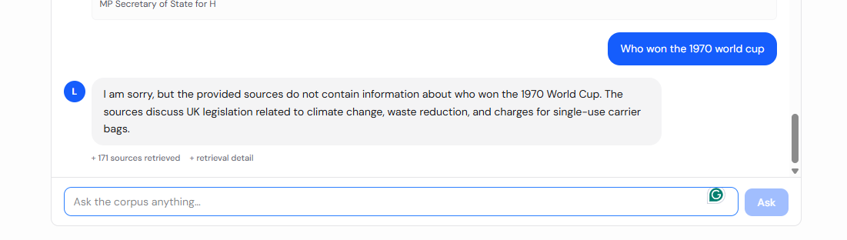
Climate change, waste reduction and carrier bags were brought up, showing it retains information from this chat.
This page is totally separate from any idea.

B – Legislation Guide
There’s nothing yet about “Reading Legislation”
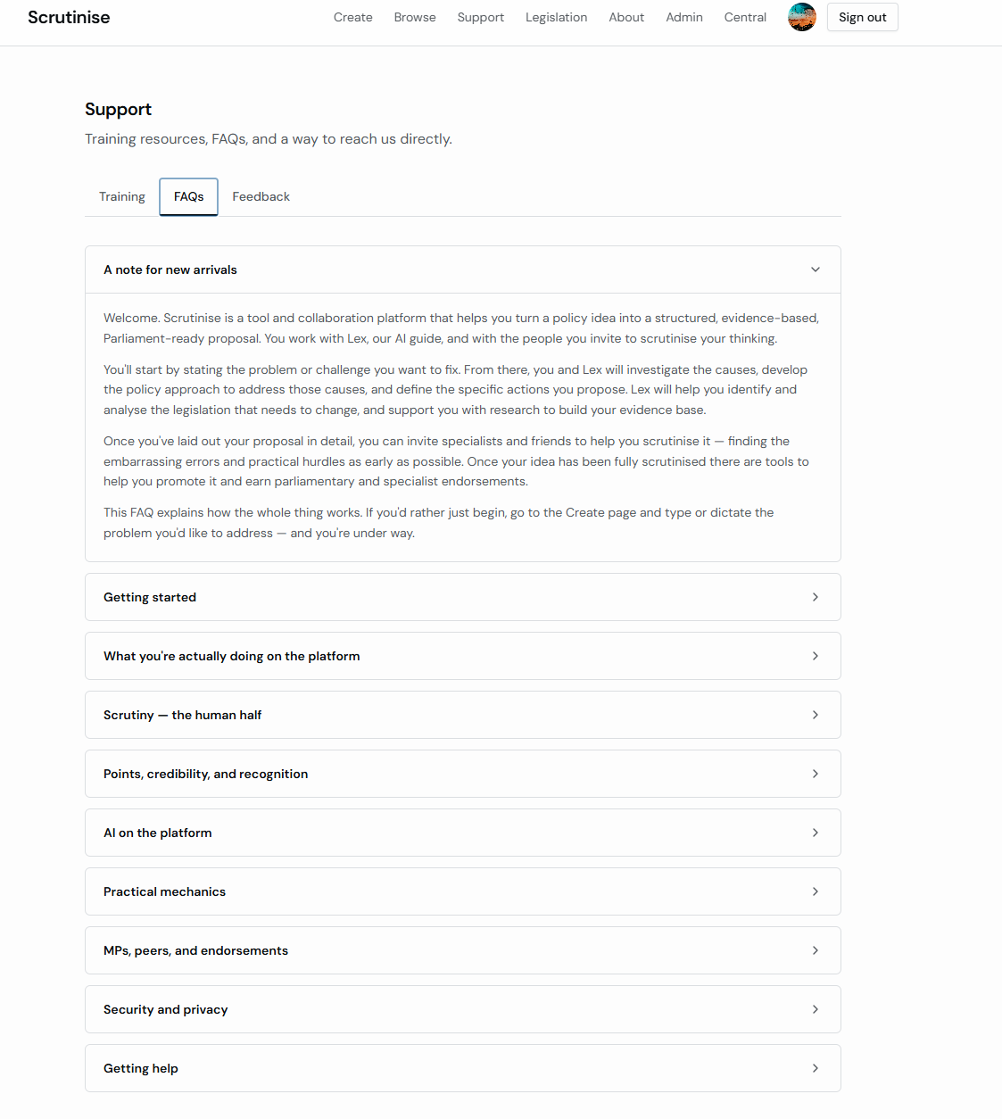
We should give it a section of its own after “What’s scrutiny and why does it matter?”
I would also like to make a small text amendment:
FROM:
“Can Scrutinise staff read my work?
Administrators have access for moderation and support purposes, but every time anyone with admin rights opens an idea that isn't theirs, it's logged with a written comment stating the reason. As the owner, you can see in your idea's Privacy Log whether any administrative access has happened, and why. The promise is: all internal human access is logged and visible to you in real time.”

TO:
“Can Scrutinise staff read my work?
Administrators have access for moderation (investigating reports of abuse) and support purposes (at your specific invitation). This is managed through transparency. Every time anyone with admin rights opens an idea that isn't theirs, it's logged with a written comment stating the reason. As the owner, you can see in your idea's Privacy Log whether any administrative access has happened, and why. The promise is: all internal human access is logged and visible to you in real time.”

C – IDEAS FLOW

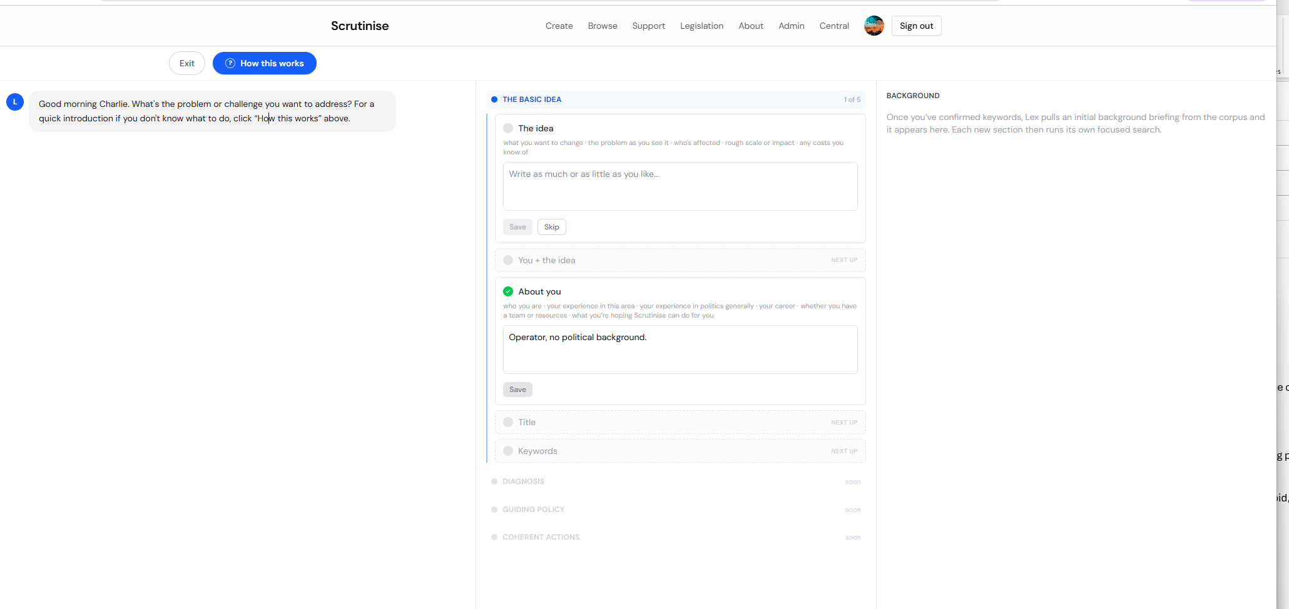
The “How this works button works well
The background has already dramatically improved:
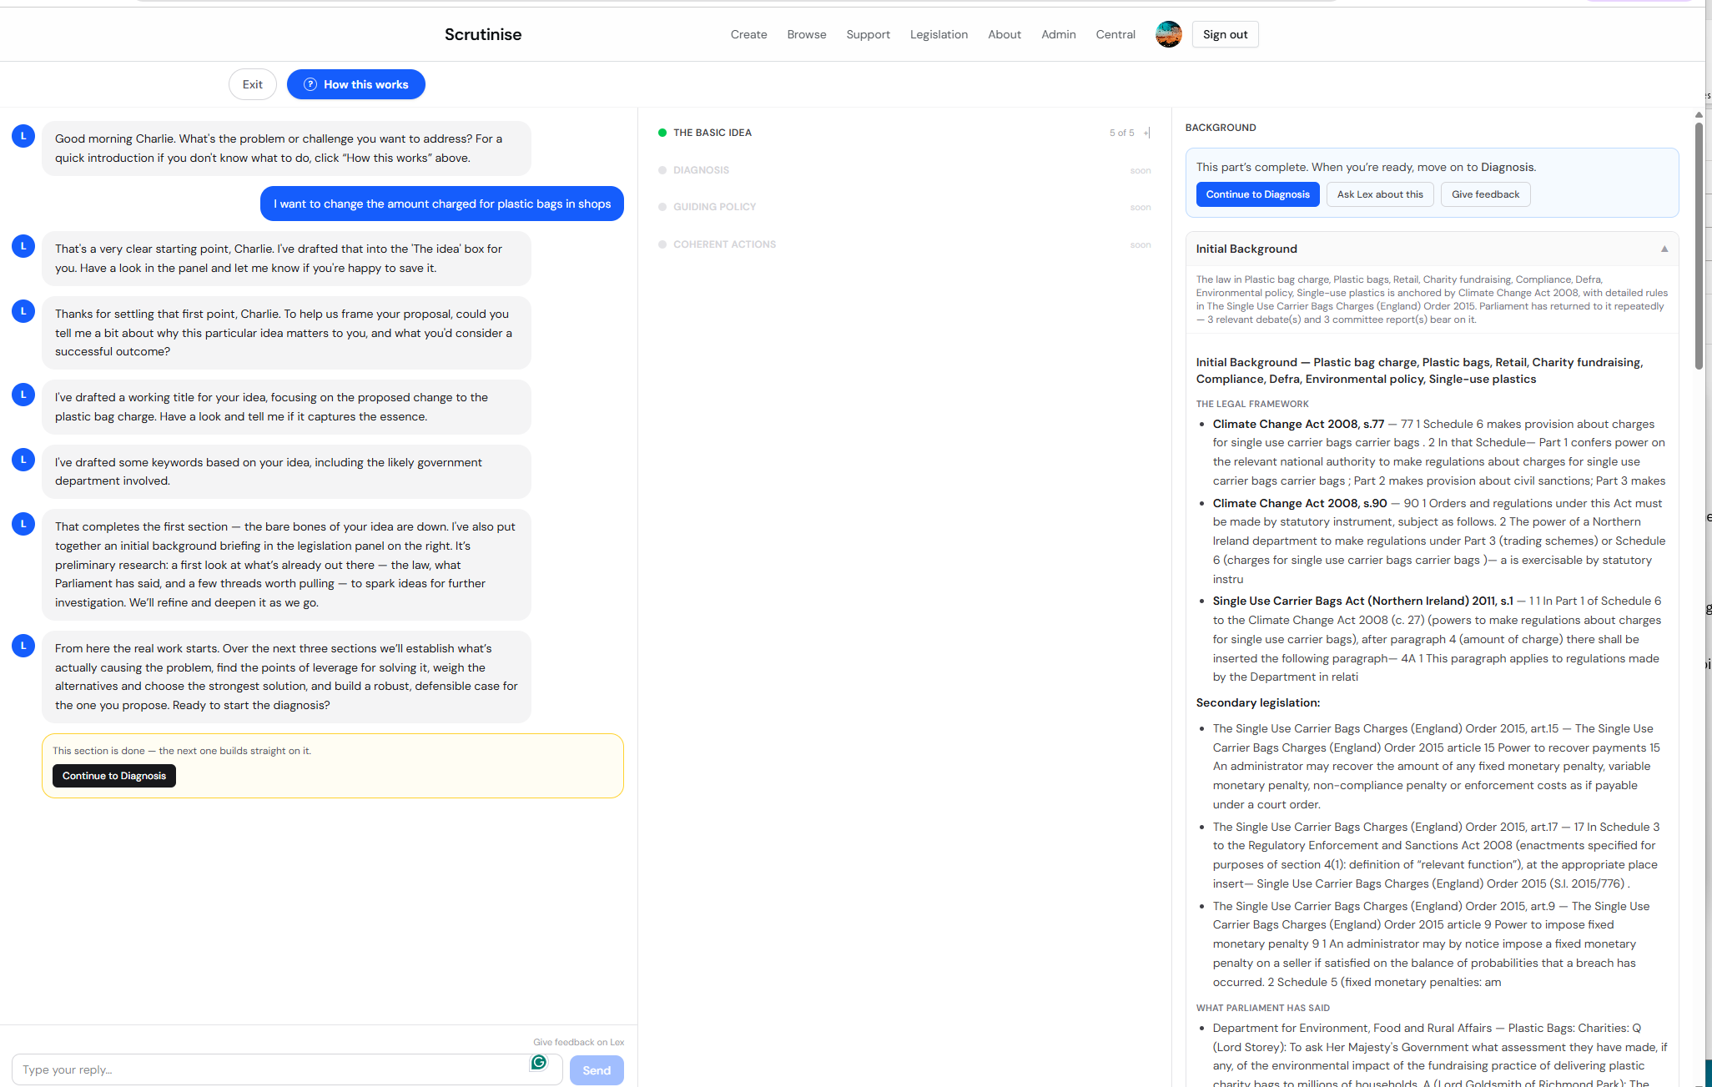
Background downloads quickly in word and pdf.
Clear message and buttons to move to diagnosis
Exit works and Edit brings you back to the same spot
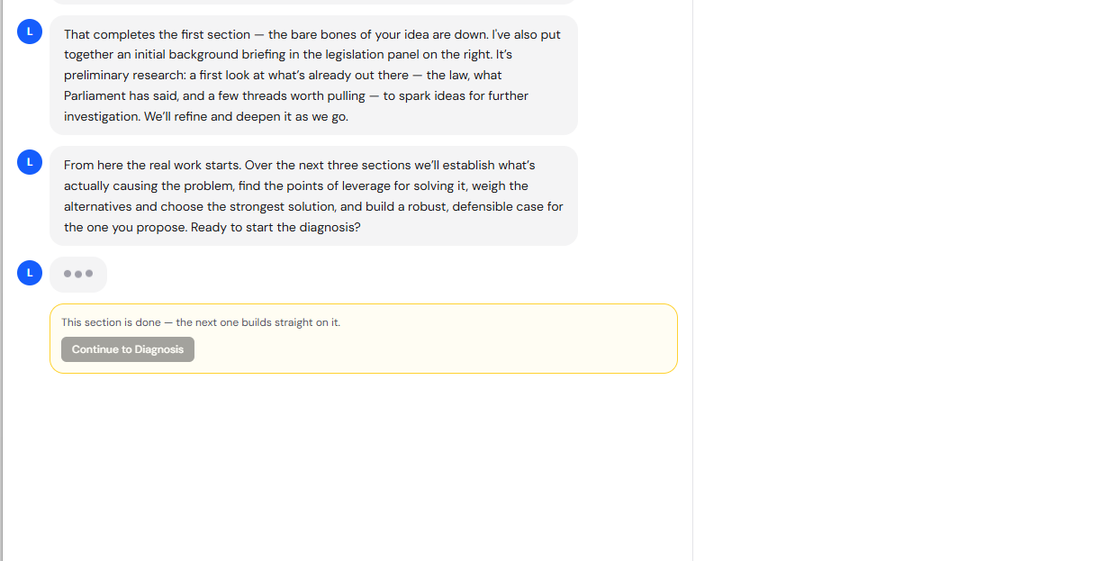
Exit prompts correctly on unsaved items:
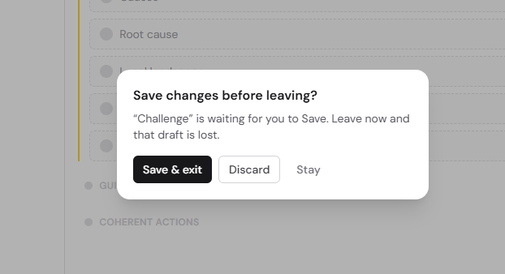
When I clicked “Save and Exit” nothing happened or rather, it may have saved data but it didn’t exit, I had to press “Discard” to exit, and there was a noticeable pause before exit. Maybe 5 seconds.

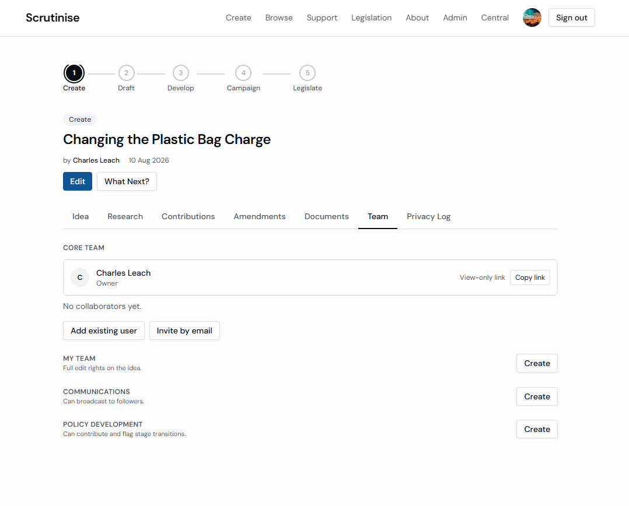
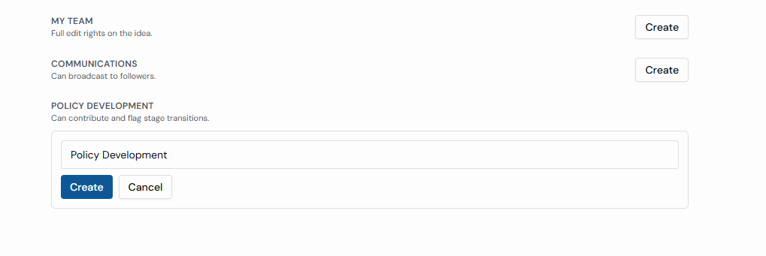Why do we need “Communications and Policy Development” in this list? What do they do? I think we can delete these, those functions sounds like roles and permissions you can attribute to a team member after inviting them? Delete from the Team page unless there’s a reason for them I have missed.
Links in the background for “Possible Relevant Legislation” don’t work,
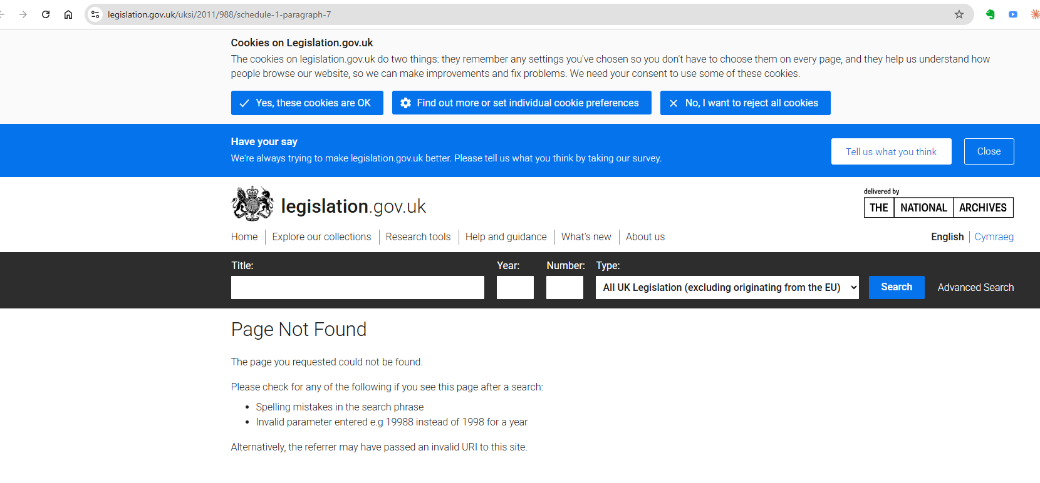
However the debates, the committee reports and the ‘anything else relevant’ links do work

I couldn’t see how/where to “Retry the search” There’s no retry/rerun button in the RH Background/legislation panel. I’m not sure why that’s needed as it’s a one-off run after the title page. Not high priority for now.
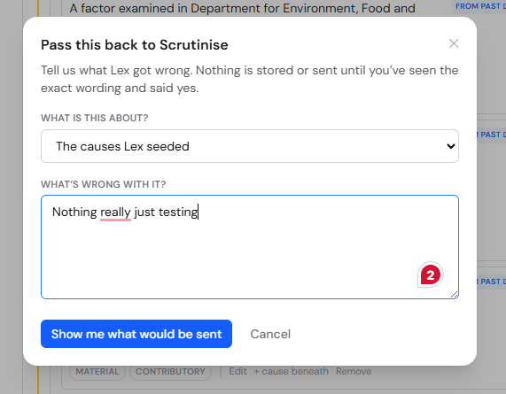
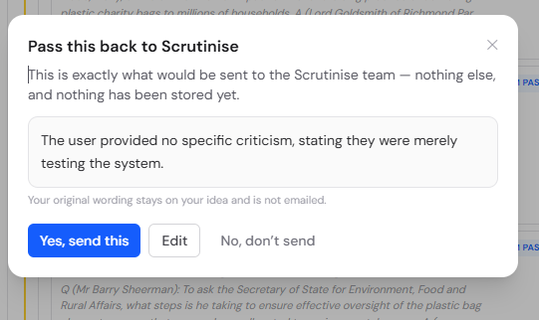

Email received
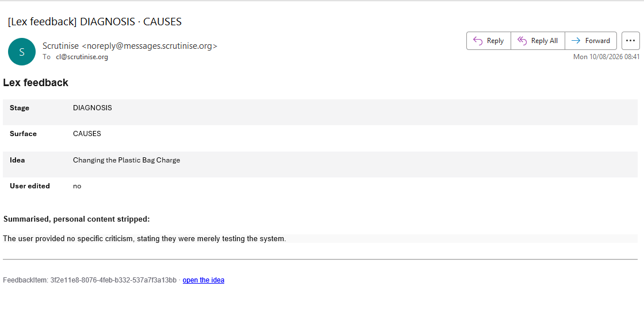
Name’s not removed. Emails are

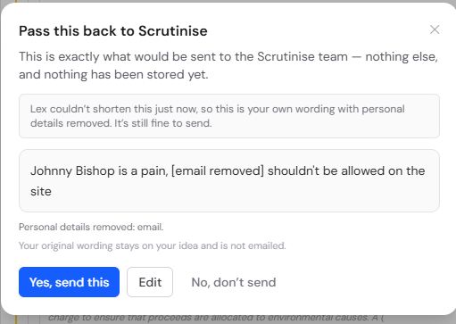

Editing worked
Feedback emails arrived

Idea Flow

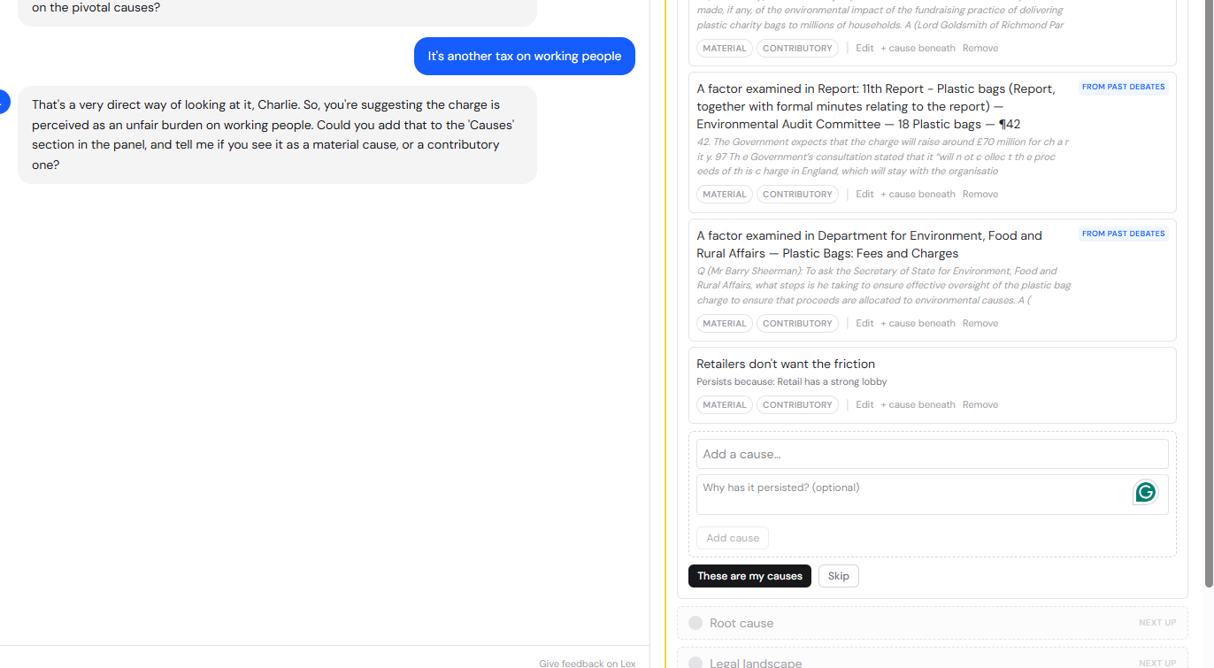
This isn’t a problem, but you can’t currently add causes via chat, Lex asks you to add it to the middle panel directly.
Tab and space to add works
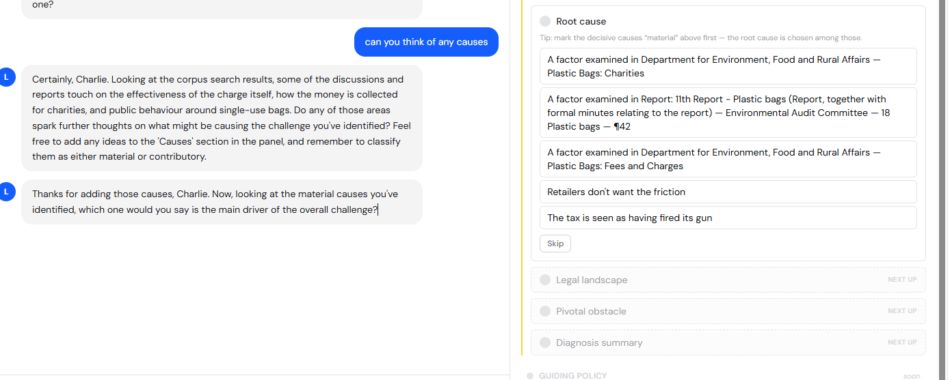
The three causes added by Lex were from the corpus – good, but not properly parsed and expressed as a cause of the problem. Need some logic checking here. “Is the idea actually expressed as a problem?” “Does this cause logically have a causatory relationship with that problem?”

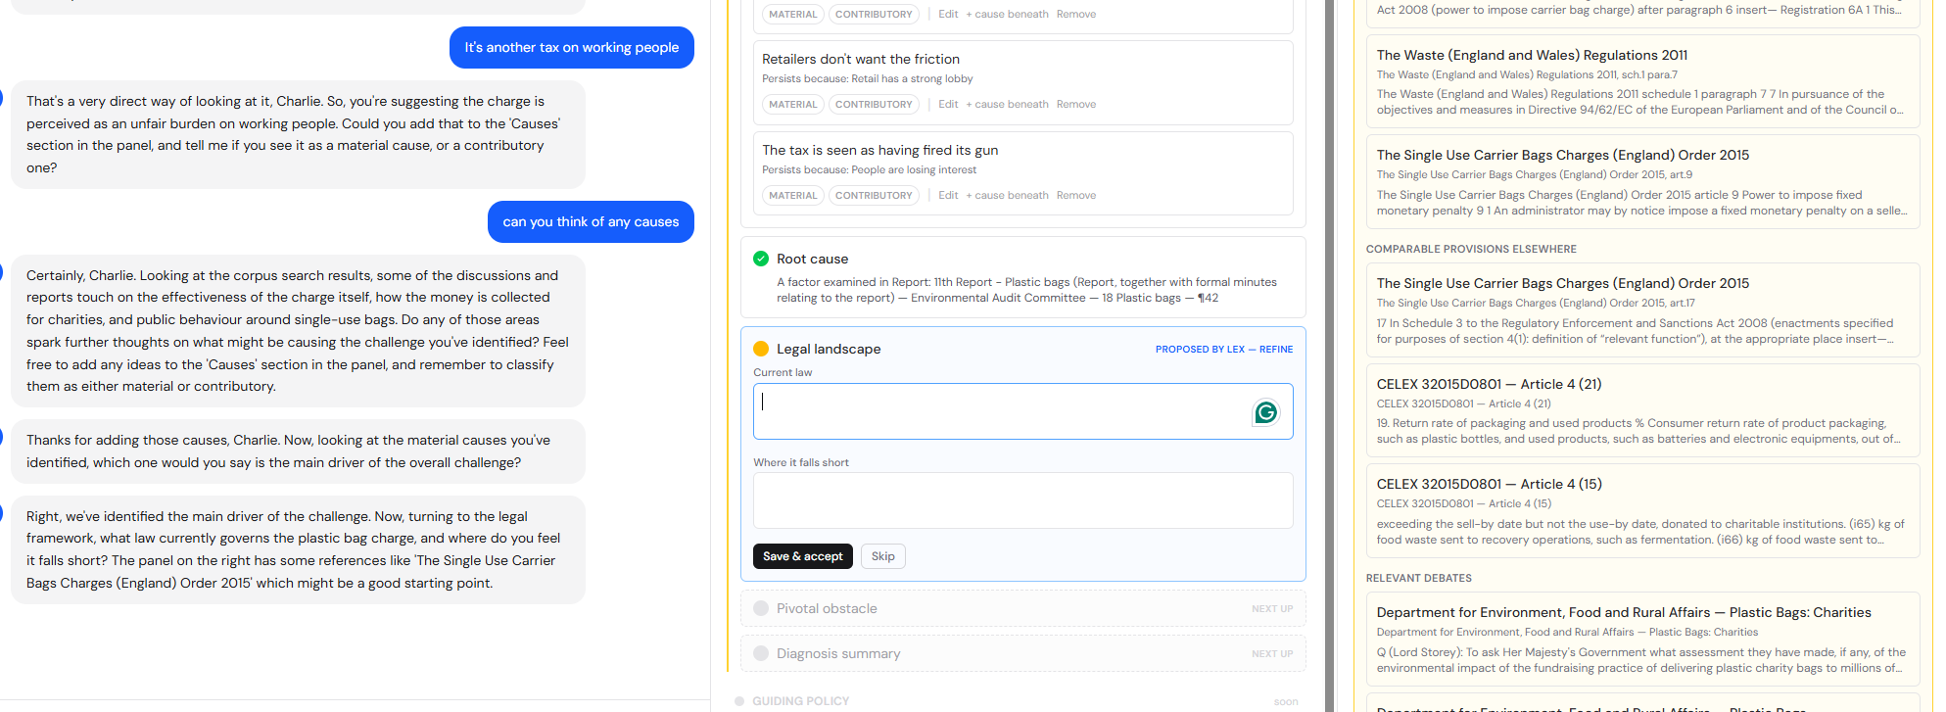
Here the Middle panel says “Proposed by Lex” but nothing is currently proposed by Lex and the LP chat asks the user to read the background and choose one, better if lex proposes but recommends the user read the background and make their own choice as they will in due course be expected to defend their proposal. However I think it’s fine to expect the user to put some thinking in here. There will be a chance to come back to this, when we do the deepening. For sure Lex should be able to propose “the current law” and legal landscape.
Lex gave a good suggested pivotal obstacle
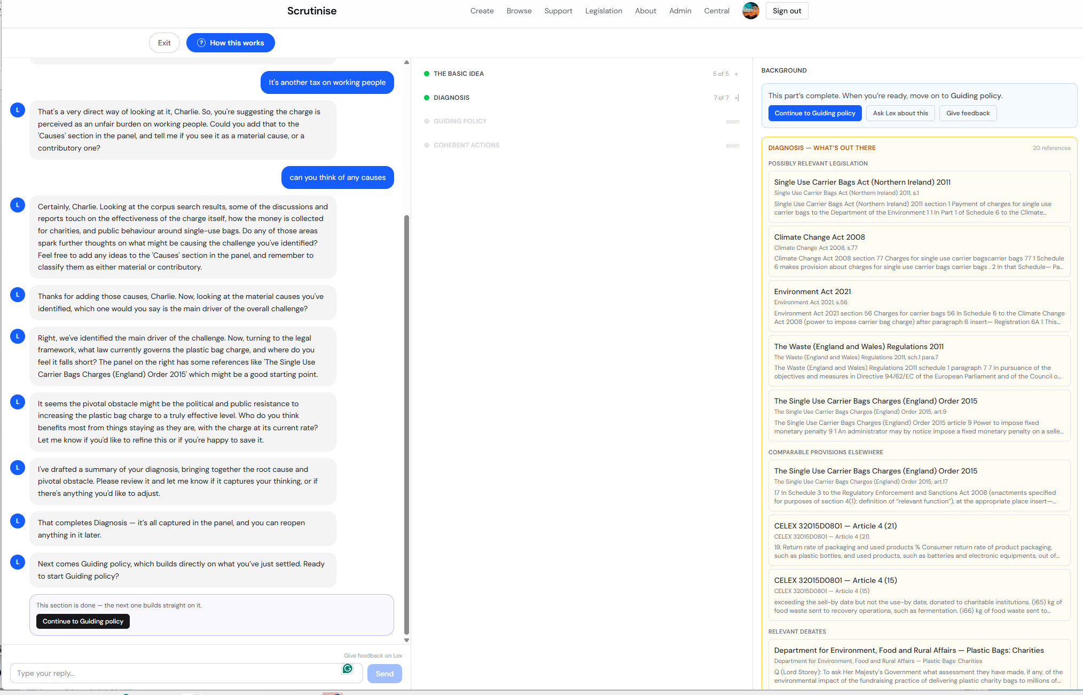
Right hand panel has switched as expected
On guiding policy RP goes back to background.
I can’t go back to add more causes once I’ve moved to Guiding policy. I can review them in MP, edit and remove them - but the LP Chat doesn’t follow.
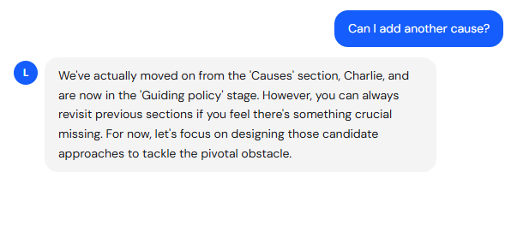
I didn’t test “Accepting the Challenge refreshes that landscape search” I couldn’t see what that meant.
I didn’t do a really long multip part answer on who’s affected but Lex did fill that out pretty well
I didn’t do a multi-level causal structure yet.
The list works but the map doesn’t yet. I think we knew that.
Not clear how to classify causes as material vs contributory
Not sure what it means to say Root cause selectable at any depth – so haven’t tested this
Back to logic: I put as an idea “I want to change the amount charged for plastic bags in shops” Lex didn’t challenge me to say what the problem is I want to solve. Without a problem we can have no strategy and the whole logical structure breaks down. I think we need to change the label “Challenge” back to “Problem”. Without a clear Problem how do you solve it. Without a clear label how do we have a clear problem. But we also need Lex to be a bit harsher in getting logical clarity off the user to identify the problem. At the moment I can put anything in and it’s accepted, and none of it makes sense. Perhaps this logical critique arrives with the deepening

I don’t know about the skip path – what does a second idea mean?
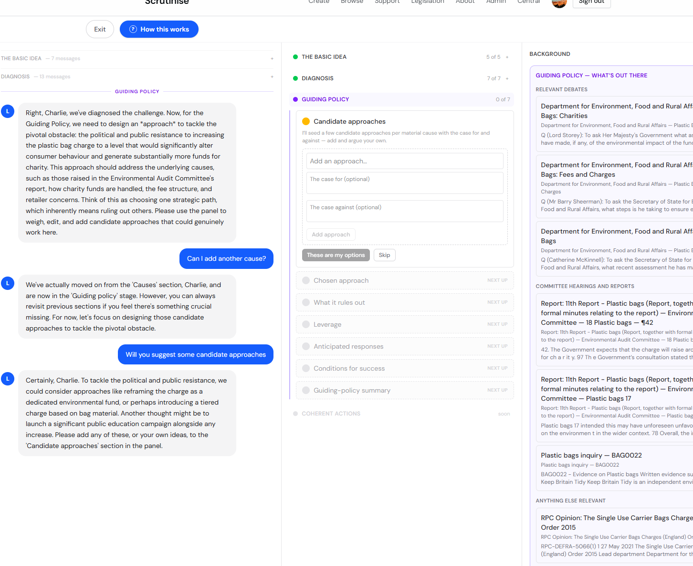
Lex not adding the MP filler in this section even though the MP says “I’ll seed a few candidate approaches per material cause with the case for and against – add and argue your own”

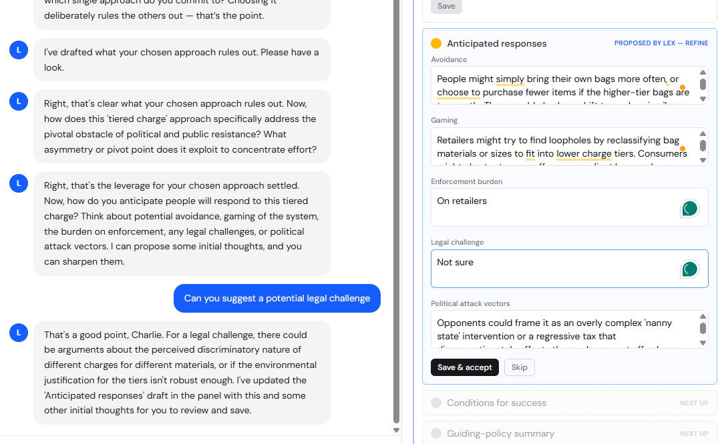
Hasn’t filled in the Enforcement burden or Legal challenge which Lex is best placed to fill in.
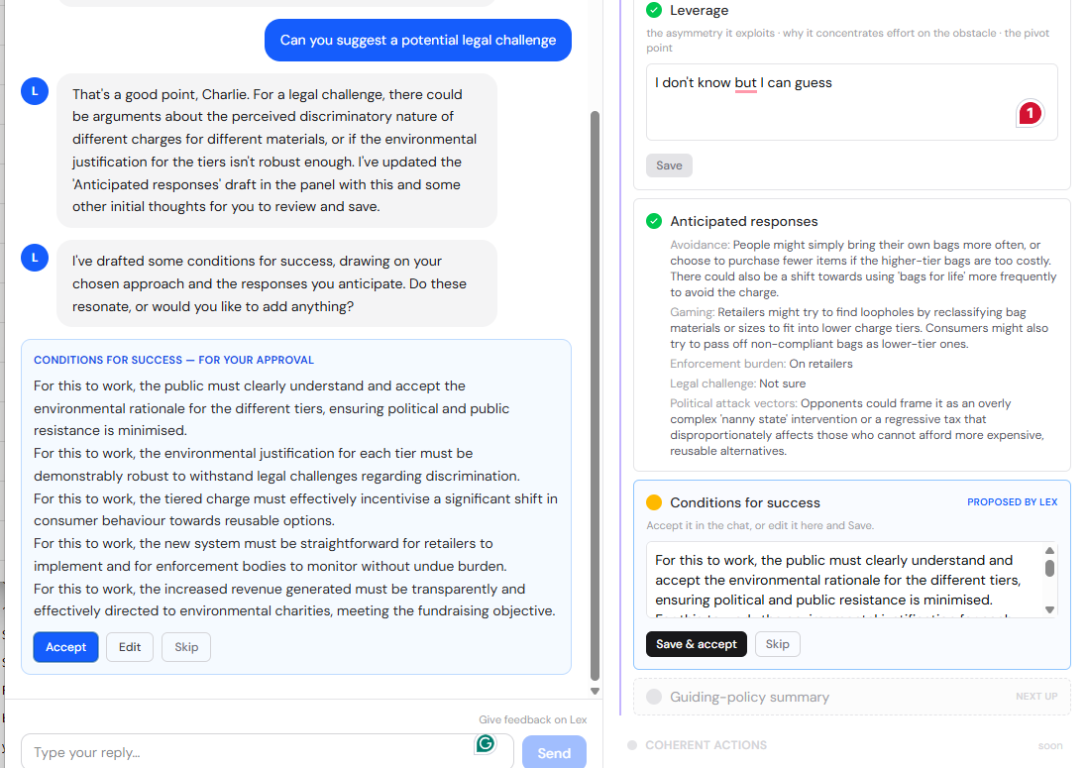
I can’t see that guiding policy approaches are seeded per material cause but maybe that’s because I didn’t have multiple material causes.
I can’t see that options cares collapse to title but I may not be looking in the right place.
I can add/edit delete my own options
Coherent Actions
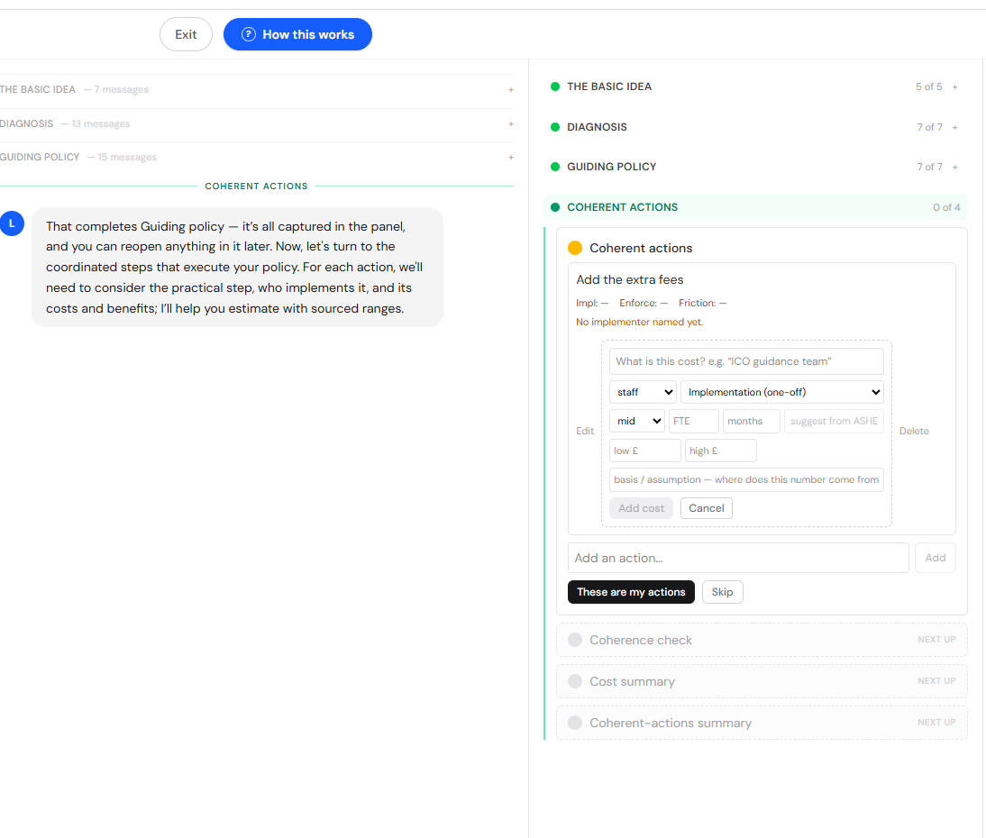Tried adding costing – works fine
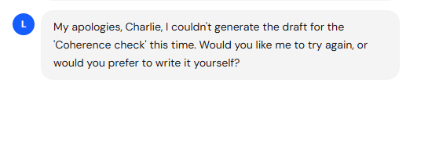
I wasn’t able to check the coherence check, I can’t go back and edit the coherent actions.Or add more coherent actions to check the Coherence check in other ways.
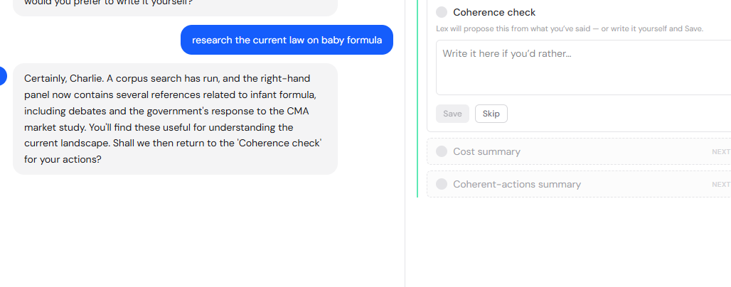
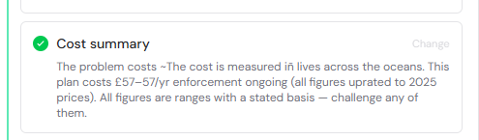
£57/year enforcement cost must be wrong
